This method will allow you to**put a custom background to your folders**.

The trick is to make your folder a system folder and then you are done with it.

Just fire open the notepad and copy paste the following code into it.

***[.ShellClassInfo]  
IconFile=%SystemRoot%\system32\SHELL32.dll  
IconIndex=141  
[{BE098140-A513-11D0-A3A4-00C04FD706EC}]  
IconArea_Image-=  
iconArea_image=<"The name and location of the wallpaper">***

save the file as **"desktop.ini"** in the folder that you want the wallpaper in.

Refresh and voila.....you are done.

The image will be **tiled**and you may not like it......

so just choose the image that matches the current resolution of your screen.

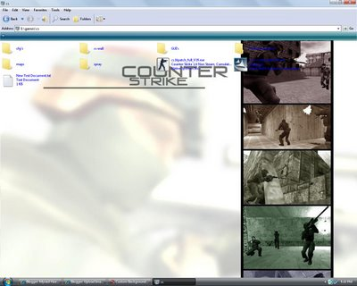

This is what I did.. to my counter strike folder.

Image resolution was 1024 x 768 and my resolution was 1280 x 1024

So I increased the image size using photoshop(you may use paint) to the next permitted level and this was it.